Enrolling onto the Academic Support Community
- When you log into blackboard you will be presented with the below on the top of your screen, click communities.
2) You will then be presented with a search box. Type in ‘academic support’ and click go.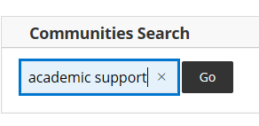
- If you hover to the right hand side of our organisation ID and arrow will appear which you can click and then press enrol.
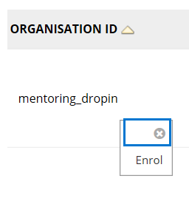
- You will be presented with the below to confirm your enrolment, click OK and you will be directed to our online resources pictured below.
