Waste Management Strategy
2020 – 2025

Version Control

Date: | Version: | Author: | Authorised by:
18/03/2020 | 1.0 | E&S Manager
08/11/2023 | 2.0 | Head of ES

Introduction

The University of West London is committed to implementing best practice in environmental management in order to reduce the overall impact of its operations.
This includes addressing key environmental impacts areas such as carbon emissions associated to waste volumes.
As a large organisation with over 12,000 students and staff (FTE), it is inevitable for the University to generate waste as a result of its operations.
It is essential that this waste is handled and disposed of in a the most sustainable manner possible; by following the waste hierarchy so as to ensure that wherever possible it is treated as a resource that has value and that can be sustainably re-used.

Purpose

The purpose of this Waste Management Strategy is to set out a framework for waste management at the University over the next 5 years from 2020 to 2025.

The first Waste Resources Action Plan was published in 2015. Since then, the University implemented a number of initiatives to comply with environmental legal requirements, manage waste in accordance with the waste hierarchy and reduce operational impact on the environment.

This new Waste Management Strategy will improve the University’s environmental performance and contribute to the ongoing certification of the Eco Campus standard for Environmental Management System (EMS). The strategy also supports the delivery of the University’s Estate Strategy (2020-2025) to ensure resource is used in the most efficient way.

Strategic objectives, targets and actions with respect to waste management is presented in this strategy.

Strategic Drivers for Waste Management

Waste Hierarchy

As stipulated by the Waste Regulations 2011, the Waste Hierarchy model is the main principle behind the University’s Waste Management Strategy. The model sets out the “most favourable” and “least favourable” options for sustainable waste management. The University aims for 100% of waste to be diverted from landfill. See Figure 1 below for the Waste Hierarchy.

Figure 1 Waste Hierarchy
Reduce
Reuse
Recycle
Recovery
Landfill
lowering the amount of waste produced
using materials repeatedly
using materials to make new products
recovering energy from waste
safe disposal of waste to landfill
Most favoured option
Least favoured option

Compliance with Legal and Other Requirements

It is a legal requirement to apply duty of care when disposing waste in the UK. Adequate provisions for handling, storage and disposing waste must be available. The University’s Waste Management Strategy will ensure all relevant legislation and other requirements relating to waste management is adhered to.

The University has implemented an Eco Campus EMS as a management tool for monitoring compliance with environmental legal and other requirements, and improving environmental performance associated with waste management. One of the requirement of Eco Campus is to demonstrate continual improvement in environmental performance. This Waste Management Strategy supports the objectives and targets set out in the Eco Campus EMS relating to waste management.

The University is committed to minimising waste through effective recycling and waste disposal as outlined in the Environmental Policy. The objectives, targets and actions set out in the Waste Management Strategy facilities the delivery of this commitment.

Incentives from Waste Resource

The University is entitled to financial benefits for selling the different waste stream to potential buyers. In line with the Waste Hierarchy, where waste cannot be reduced, it will then be re-used by others who purchase the waste from the University. In return, the University will receive a rebate for the sold item. The University has the facility to sell stacked baled cardboard and plastic bottles to generate revenue.

Stakeholder Management

As a public sector organisation, the University has a number of stakeholders who have interest in its environmental activities such as waste and recycling. This includes staff, students, neighbours, local authority and funding bodies, as well as external reporting bodies such as for HESA Estates Management Statistics and the People and Green Planet League.

Current Performance

During the recent academic year, 1st August 2021 to 31st July 2022, the University produced 155 tonnes of waste of which 79% was incinerated, 17% was recycled and the remaining 3% was disposed through anaerobic digestion. There was no waste sent to landfill. Figure 2 below shows a breakdown of waste and the disposal route from 2015/16 to 2021/22.

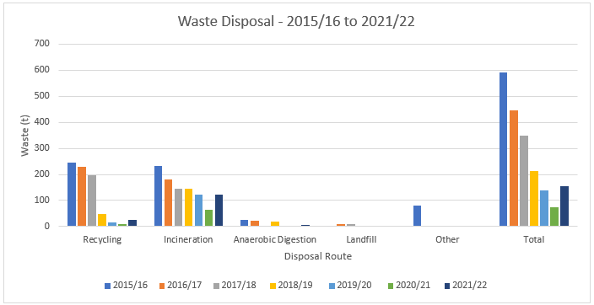
Figure 2 Waste Breakdown by Disposal Route (2015/16 to 2021/22)

Further analysis of the waste data shows the University’s total waste increased significantly by 111% in 2021/22 compared to the previous year (2020/21), and this is most likely due to the return of staff and students back to campus following Covid-19.

The recycling rate increased noticeably by +152% in 2021/22 compared to 2020/21. However, recycling as a proportion of total waste was only 17%. This Waste Management Strategy sets out an action plan on how to increase recycling from 2020 to 2025. See Table 1 below for a summary of the recycling performance since 2015/16.

Table 1 Waste Performance (2015/16 to 2021/22)
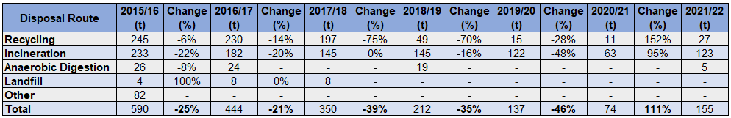

Objectives, Targets and Action Plan (2020 to 2025)

Objectives

This Waste Management Strategy supports the overarching waste objective set out in the Environmental Policy; “minimise waste through effective recycling and waste disposal”.

The following strategic objectives is set and this supports the delivery of the Environmental Policy:
- Ensure best practice in waste management is adopted across the operation in line with the Waste Hierarchy.
- Continually improve the environmental performance relating to waste management. This should be achieved in line with national environmental objectives.
- At all times comply with legal and other requirements relating to waste management, including the Eco Campus EMS.
- Engage staff and students on waste management through awareness raising initiatives.

Targets and Action Plan

Table 2 below presents the targets and actions to deliver to the objectives.

Table 2 Targets and Action Plan (2020 to 2025)
Target | Action | Owner | Timeframe
Reduce
Reduce the amount of waste generated each year by 1% from 2015/16 baseline | Set all printers to default setting of double-sided printing | PSD / IT | 2021
 | Encourage staff to use re-usable cups and bottles for hot/cold drinks | PSD / Catering | Ongoing
 | Support Catering suppliers to reduce packaging waste | PSD / Catering | Ongoing
Reuse
 | Create accounts on online selling platforms such as Gumtree and Ebay to sell old electrical items | PSD / IT | 2022
Offer 100% unsold food items due to expire on the day to staff / students | Develop a policy for raising awareness to catering departments | PSD / Catering | 2022
Re-use pallets and roll cages by offering it to suppliers to take back during deliveries | Liaise with suppliers to ensure they take back the pallets and roll cages after delivery so that it is not left in the waste compound | PSD / Catering | Ongoing
Recycle and Recovery
Increase recycling to 25% by end of 2025 | Install the correct infrastructure at front and back operation to facilitate recycling e.g. correct number and types of bins, bin bags, signage, baler etc. | PSD / TFM Contractor | 2021
 | Deliver awareness raising training to catering contractors who use the Waste Compound so they are aware on the process for handling and storing waste | PSD / Catering | Ongoing
 | Participate in global and national events relating to recycling and waste management by setting up stalls | PSD | Ongoing
 | Develop a communications plan to raise awareness about recycling to staff, students and contractors | PSD / Marketing | 2021
 | Create a guide which includes information about which waste stream can be recycled and where to store it | PSD / Marketing | 2021
 | Appoint Waste Operator to support recycling and manage Waste Compound | PSD / TFM Contractor | 2021
Divert 100% of waste away from landfill | Liaise with waste contractor to ensure any waste that cannot be recycled is then turned into energy through incineration | PSD / TFM Contractor | 2021
Legal and Other Requirements
Comply with all applicable environmental legal and other requirements relating to waste management | Maintain Eco Campus EMS accreditation to demonstrate compliance with environmental legal and other requirements. | PSD | Ongoing

Monitor and Review

Data from the Waste Contractor will be collected monthly and therefore performance will be monitored at least once a month. The recycling performance will be presented to the Environmental Operations Group (EOG).

The targets and actions will be monitored and reviewed annually during the last EOG in each academic year.

A full review of this Waste Management Strategy will take place at the beginning of 2026 following the implementation of the initial 5 years of the strategy.

All monitoring and review activities will be undertake in accordance with the University’s EcoCampus EMS policy and procedures.

